Strategic analysis of JCPenny Company
Student’s Name
Institutional Affiliation
Date

Strategic analysis of J.C. Penny Company
Introduction
The company chosen for this assignment is J.C. Penny, an American departmental store that sells conventional merchandise, jewelry, footwear, apparel, accessories, and beauty products. It ranked 286 in Fortune 500 companies in 2020. The total return to investors in the last five years is -29.6%. Citing the effects of coronavirus, the 118-year old department store filed chapter 11 bankruptcy protection in May 2020. During the same period, J.C. Penny announced the closure of 242 stores, among the many stores it has closed in recent years. Clearly, the company is on its deathbed. The company faces stiff competition from companies offering similar products like Gap, Kohl’s, and Macy’s (Ofek et al. 2016). This has had devastating impacts on the company. A huge task lies ahead of turning the financial situation of the company around. Something has to be done to salvage the situation. This paper offers strategies for achieving a sustainable competitive advantage in the marketplace and increasing this nearly dead company's financial performance.
Current financial plan
Fortune 500 ranking
From the diagram below, we can see that the company's position in the Fortune 500 rankings has been dropping every year. The latest ranking was in 2020, where it ranked 286, its worst in history.
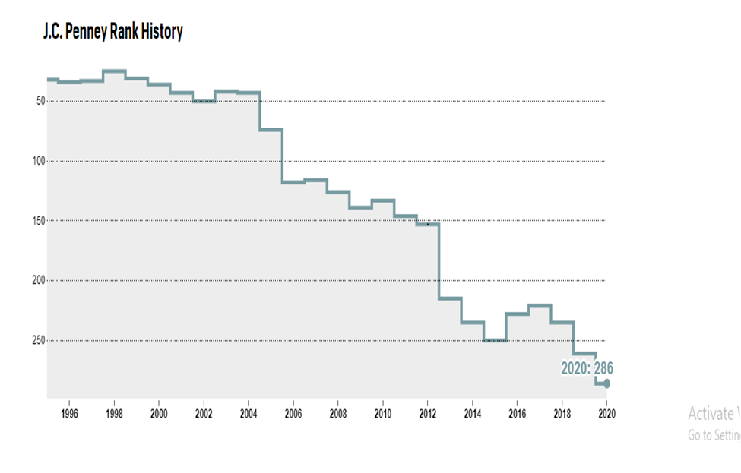
J.C. Penny Finances from 2010-2018
Year | Revenue  (in mil. USD) | Net income  (in mil. USD) | Total Assets  (In mil. USD) | Employees | No. of stores
2010 | 17, 556 | 251 | 12,581 | 154,000 | 1,108
2011 | 17,759 | 389 | 13,068 | 156,000 | 1,106
2012 | 17,260 | -152 | 11,424 | 159,000 | 1,102
2013 | 12,895 | -985 | 9,781 | 116,000 | 1,104
2014 | 11,859 | -1278 | 11,801 | 117,000 | 1,094
2015 | 12,257 | -717 | 10,309 | 114,000 | 1,062
2016 | 12,625 | -513 | 9,442 | 105,000 | 1,021
2017 | 12,547 | 1 | 9,118 | 106,000 | 1,013
2018 | 12,505 | -116 | 8413 | 98000 | 872

The table above proves the financial crisis that J.C. Penny has been experiencing in at least the last eight years. The revenue and net income have been decreasing since 2010. Similarly, the assets and number of employees have been dropping drastically. The company has also closed numerous stores. This information shows that the company has been facing financial difficulties, and in May 2020, it filed for bankruptcy.
Competitive strategies
One of JCPenny's strategies to turn its fortunes around and avoid the imminent closure is by pursuing a merger with another company. One of the possible mergers it could pursue is eBay and Amazon because they are currently doing very well. Other possible solutions would be Kmart, Macy's, and Target, but they are also experiencing a financial decline. With the merger, the company can regain its market share. Mergers have been helpful to collapsing companies, a situation in which JCPenny is in now (Byron, 2017).
Another strategy that the company can use to revert its misfortunes is by embracing and expanding its social media platforms. According to Tonya (2017), social media marketing has become a common strategy to many companies, and JCPenny should embrace it. Nowadays, companies are using social media platforms such as Facebook, Twitter, LinkedIn, and Instagram to market their products. Tonya (2017) suggests that the company should learn from Amazon, which is now the biggest online shopping company. J.C. Penny can use social media platforms for advertising its products and allow its customers to shop online. Social media also helps connect different age groups and genders. In a world where Millennials make the biggest portion of the population, social media marketing provides the century's best marketing strategy. With the help of younger internet-savvy employees, Penny can identify the trending topics on the social media platforms. For example, using Twitter, the employees can create a hashtag for the goods to be advertised that can go viral easily and create awareness of the product. The company can use social media platforms to learn its strengths and weaknesses, hits and misses. A lot of information can be gathered from the platforms. By looking at the comments section, the company can know what the customers need. The company can also understand the needs of the customers so that it can fully satisfy those needs. The trending issues in the market can also be gotten from the comments section. The company can also learn what its competitors are doing right so that it can replicate it. The criticism from the followers and customers can also make the company improve its services and come back to the market stronger. E-commerce and telemarketing go hand in hand with social media marketing. The company should consider using these strategies to revive its operations. History seems to favor e-commerce for the company. The company's e-commerce storefront hit the one billion dollar mark in 2005 (Byron, 2017).
Another way J.C. Penny can gain strategic and financial positioning is by lowering the prices of its items. Lowering prices is one of the strategies of attracting customers. However, this applies if the quality of the product is not compromised. Penny can apply this strategy to fend off its competitors and come back to the market. Although such measures may be difficult to implement due to different partnerships that dictate the price of items, it might be the only option to go by given the bad conditions that the company is in right now.
Plan to implement the strategies
The best strategy to implement would be implementing the social media aspect. Compared to other methods, embracing social media in marketing would turn the situation of J.C. Penny around. Getting exposure on social media will make the company attract new customers across the globe. The merger option is the least applicable. Making a merger can be quite difficult because the other partner may not be willing to enter the merger. Considering that the other similar companies like Macy's, Target, and Gap are also experiencing financial problems, it can be difficult to partner to a merger. The other alternative is Amazon, which is doing very well, which means it is equally difficult to secure a merger. Reducing the prices of the commodities is a considerable option. However, reducing the pricing might put the company in further losses since customers will shift to cheap alternative products. Lowering the price of products is a strategy mainly used by businesses seeking to enter the market, but the strategy cannot be replicated to a dying company. The company is bound to make more losses. This leaves social media marketing as the best option to implement. Since the company is already popular with most people, J.C. Penny can follow trends and make jokes on current events to engage on the internet. This move would salvage this general merchandise company from its imminent death.
I believe that despite the seemingly inevitable death of J.C. Penny if this strategy is applied effectively, the company will bounce back and return to its profit-making ways. Despite the company’s financial woes, it is not late to salvage the situation. Penny can still reinvent itself. The company does not have a major debt repayment due until 2023, thus, it is too early to call it quits (Sun, 2020). It is still possible to turn things around.

References
Byron, E. (2017). America's retailers have a new target customer: the 26-year-old millennial. Wall Street Journal. Retrieved in, 18.
Holst, M., & Hansen, S. (2017). Competing for Survival: A Turnaround of Department Store JC Penney.
OFEK, E., STEWART, K. S., & SNIVELY, C. (2016). JCPenney: Back in Business.
Sun, L. (2020, January 19). 3 Ways J.C. Penney Can Still Reinvent Itself. Retrieved September 28, 2020, from https://www.fool.com/investing/2020/01/19/3-ways-jc-penney-can-still-reinvent-itself.aspx
Tonya G. (2017). "J.C. Penney targets millennials with a return to the appliance business." Archived from the original on July 2, 2017. Retrieved March 2, 2017

